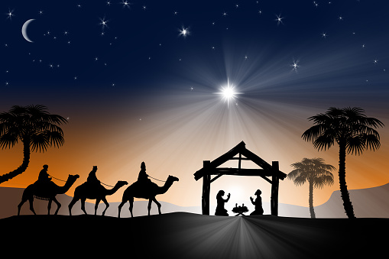

KINGDOM KIDS 2023

ART SPIN SONGS December 9th, 2023
3 PM (2:30 PM Call) Wilson Arts Center

Jingle bells – Pierpont F major
Jingle bells, jingle bells Jingle all the way Oh, what fun it is to ride In a one-horse open sleigh, hey! Jingle bells, jingle bells Jingle all the way Oh what fun it is to ride In a one-horse open sleigh
(normal-interlude-slow-fast-faster!)
Frosty The Snowman-Rollins/Nelson B-flat major
Frosty the Snowman, was a jolly happy soul,
With a corn cob pipe and a button nose, and two eyes made of coal.
Frosty the Snowman, is a fairytale, they say.
He was made of snow, but the children know he came to life one day.
There must have been some magic in that old silk hat they found,
For when they placed it on his head, he began to dance around!
Oh, Frosty, the Snowman, was alive as he could be;
and the children say he could laugh and play,
just the same as you and me.
Thumpety thump, thump, thumpety thump, thump,
look at Frosty go.
Thumpety thump, thump, thumpety thump, thump,
over the hills of snow.

Follow The Star- Jablonski/Morehead with Veni Emmanuel e
Twinkle twinkle little star
God has made you what you are
Up above the world so bright
Shine your light all through the night.

Follow the star, oh follow
Oh follow oh follow the star.

Follow the star, oh follow
Oh follow oh follow the star.

While We Are Waiting Come-Cloninger F major/G major

While we are waiting, come
While we are waiting, come
Jesus our Lord, Emmanuel,
While we are waiting, come

With pow'r and glory, come
With pow'r and glory, come
Jesus our Lord Emmanuel
With pow'r and glory, come
Come, Christians Join To Sing-French carol F# major-G major
Come, Christians, join to sing
Alleluia! Amen!
Loud praise to Christ our King;
Alleluia! Amen!
Let all, with heart and voice,
Before His throne rejoice;
Praise is His gracious choice;
Alleluia! Amen!

Jesus, What A Wonderful Child-African American Spiritual G
Jesus, Jesus, O what a wonderful child.
Jesus, Jesus, so holy, meek and mild;
New life, new hope the child will bring
Listen to the angels sing:
“Glory, glory, glory!” Let the heavens ring. ( Interlude/ Repeat)

